Stem cell researchers under pressure to produce

Stephanie M. Lee

Published 2:40 pm, Friday, July 4, 2014
- 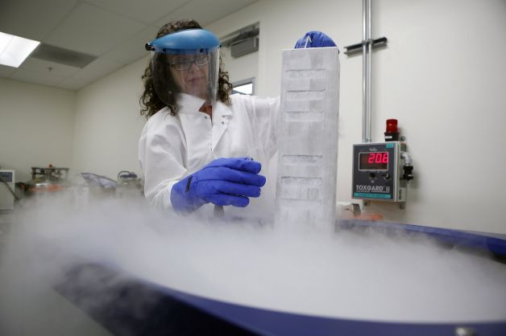
Director of Neurobiology Alexandra Capela displays a case of neural stem cells in a liquid nitrogen case, above, at Stem Cells Inc. in Newark. Photo: Michael Short, The Chronicle | Buy this photo

In laboratories across California, scientists are racing to turn stem cells into therapies for some of the world's most debilitating illnesses from cancer to Alzheimer's.
Many of those researchers have received funding from a unique source: California's stem cell agency. Created by voters a decade ago, the California Institute for Regenerative Medicine is authorized to spend $3 billion in taxpayer money on stem cell research and has so far doled out more than half of that in grants and loans.
Scientists have deepened their understanding of stem cells' novel potential to develop into different cell types in the body. But the clock is ticking: the agency must spend what remains of its state bonds by 2017.
Fund recipients are under pressure to show results - commercially viable therapies, ideally. Universities and other nonprofit groups have received most of the money, but the pressure is especially heavy on biotechnology companies that have staked their livelihoods on such therapies.
What the stem cell agency has done, companies and analysts say, is help fund the crucial early research - the work that indicates, not guarantees, that a therapy might be effective and safe in humans. But these discoveries are still years from clearing regulatory approvals and reaching consumers.
Critics say this process has been too slow. Researchers argue that scientific breakthroughs don't happen on a pre-determined schedule or budget.

Larger studies
"The biggest challenge for most of them has been simply moving the scientific process far enough along so that we're able to demonstrate the results in larger types of studies," saidKeay Nakae, a senior research analyst with Ascendiant Capital, an investment banking and financial advisory company.
California voters approved creation of the agency in 2004, three years after PresidentGeorge W. Bush banned the use of federal funds on research with embryonic stem cells, which can turn into virtually any type of tissue in the body.
Since then, scientists have learned more about stem cells, which in many tissues can serve as an internal repair system. They can divide endlessly to replenish other cells and can be induced to become tissue- or organ-specific cells, such as muscle or red blood cells.
Manipulated the right way, these cells could generate replacements for cells lost through injuries and diseases, scientists believe. That ability could change treatments for debilitating diseases that have no known cures.
The agency has spent $1.8 billion so far, and most has gone to universities and nonprofit institutes. About $143 million has gone to companies, either to pay for research projects in full or supplement research funded through other means.
In small clinical trials, Newark company StemCells Inc. is testing stem cell therapies for spinal cord injuries, a rare central nervous system disorder, and the eye disease called dry age-related macular degeneration. The stem cell agency is giving it a $19 million forgivable loan to study how stem cells might treat Alzheimer's disease.
"We're a publicly traded company, and the marketplace has funded our efforts to date through the sale of stock in the company," said Martin McGlynn, StemCells' president and CEO. "But we would not have been able to undertake another program, and certainly one as challenging and as risky as Alzheimer's, were it not for the fact that (the California Institute for Regenerative Medicine) was willing to provide funding to us."

Funding for trials
Stem cells are new and challenging territory, as Geron in Menlo Park learned in 2011. The company was running the world's first clinical trial of a therapy using human embryonic stem cells to treat spinal cord injuries when it halted the trial, citing a lack of funding. The stem cell agency had given Geron a $25 million loan for the trial, which the company has since repaid with interest.

Michael J. Fox Foundation for Parkinson's Research Invites Proposals for Target Pipeline Program
JULY 6, 2014
DEADLINE: OCTOBER 29, 2014 (PRE-PROPOSALS)

The Michael J. Fox Foundation for Parkinson's Research, which seeks to stimulate development of Parkinson's disease therapeutics, is accepting pre-proposals for the spring cycle of its Target Validation program.
Part of the foundation’s annual Edmond J. Safra Core Programs for PD Research, the Target Validation program supports work seeking to determine whether manipulating a novel biological target has impact in a Parkinson’s disease-relevant animal model -- an essential early step to the development of potentially promising therapies.
The program supports two-year grants of up to $250,000. Total annual direct costs cannot exceed $100,000, and no more than 2 percent (academic institutions) or 10 percent (for-profit organizations) may go to indirect costs.
Eligible applicants include biotechnology/pharmaceutical companies, other for-profit entities, public and private nonprofit universities, colleges, hospitals, laboratories, and government agencies.
As therapeutic programs may require many kinds of expertise, MJFF encourages industry and academic collaborations when appropriate. Given the significant coordination and leadership necessary for the program, postdoctoral fellows are not eligible to apply as principal investigators.
For consideration, pre-proposals must be received no later than October 29, 2014. Upon review, selected applicants will be invited to submit full proposals by November 19.
An informational conference call will be held for applicants on September 19, 2014. (An RSVP is required.)
Visit the MJFF website for complete program guidelines, an FAQ, application procedures, and to RSVP for the conference call.

